Internal Training Session Brief: Access

Control System

Session dates:
21st Jan 2025 - 23rd Jan 2025

Objectives:
Learners will be able to:

- Understand what Access Control Systems are
- Compare the access control systems Nexudus integrates with and understand what considerations should be taken into account
- Demonstrate how to set up some of the key access control system

Considerations for this session:
- Access to control systems? (will be added after the session with Marcin)

Script:

Intro
Thanks, everybody for joining today.

Our focus in this session will be Access Control Systems.

The session will be split into 3 sections of around 15 minutes each, where we’ll cover:
- Learn:
  - What are Access Control Systems and why are they needed
  - Which access control integrations are available
  - Considerations when choosing an integration
- Do: Set up one of the key ACS integrations (Openpath)
- Apply: How this knowledge can be applied to your role (to be decided if this is required or just a quiz)

Section 1: Learn (15 minutes)

Intro
Let’s start by understanding what access control systems are.

Question to the group: What are Access Control Systems?

Answer: Access control systems are a safe and convenient way to remotely control who can access the space and use its amenities.

- Door locks in a particular space are linked to the access control system, where access groups are created. Access groups define a selection of doors customers can unlock if they are part of the group.

- Each access group created should include all the doors customers need to unlock to access an area of a space or a specific resource.

- These access groups are linked to various Nexudus items such as passes, desks, offices, or resources. Customers are automatically added to the linked access groups when they purchase a pass, book a resource, or rent a desk.

Question: Why use an Access Control System?

Answer: Access control systems can improve space operations in several ways:

- Extending the opening hours: Customers can access different areas of your space and unlock doors independently, even when staff is not physically present.

- Increasing security: Customers can only access areas and unlock doors if they're part of an access group that grants them these access rights.

- Getting accurate occupancy reports: Customers are checked in and out as they unlock doors in your space, which improves the accuracy of occupancy reports for resources, desks, and offices.

Considerations while choosing an access control system:

The access control system that is right for your space will depend on several factors such as:

- What is the Space’s budget
- How does the space want its customers to unlock doors
- The country where the space operates

Depending on the access control system, customers can unlock doors with an access card, a key fob, a pin code, the Access Control Systems own app, the Nexudus White-label Passport app, or scanning an automation tile with the Nexudus Passport app.

Another factor when choosing which access control system is right for your space is whether you'd prefer an on-premise or cloud-based software.

On-premise software is installed on one or more devices and can only be used on the devices where you install it. Cloud-based software can be accessed via any web browser by logging in using admin credentials, just like Nexudus!

Any questions?

Question: There are 12 access control systems currently integrated with Nexudus… How many can you name?

Say - We do not expect you to remember all the access control systems. How many can you name?

There are following 12 access control systems that Nexudus integrates with -
- Brivo
- Avigilon Alta (Openpath)
- Kisi
- Salto KS
- Doordeck
- ACT365
- Avigilon
- Doorflow
- Gallagher
- Genetec
- Padword
- Paxton NET2

Question: Of these, how many are compatible with the White Label App?

Say- The following 5 ACS are compatible with White label app –
- Brivo
- Avigilon Alta (Openpath)
- Kisi
- Salto KS
- Doordeck

Question: Which supports check-in/check-out?

Say- The following ACS supports check-in/check-out -
- Brivo
- Avigilon Alta (Openpath)
- Kisi
- Salto KS
- ACT365
- Doorflow
- Gallagher
- Paxton NET2

Supported Access Control Integrations

Nexudus integrates with the following access control systems:
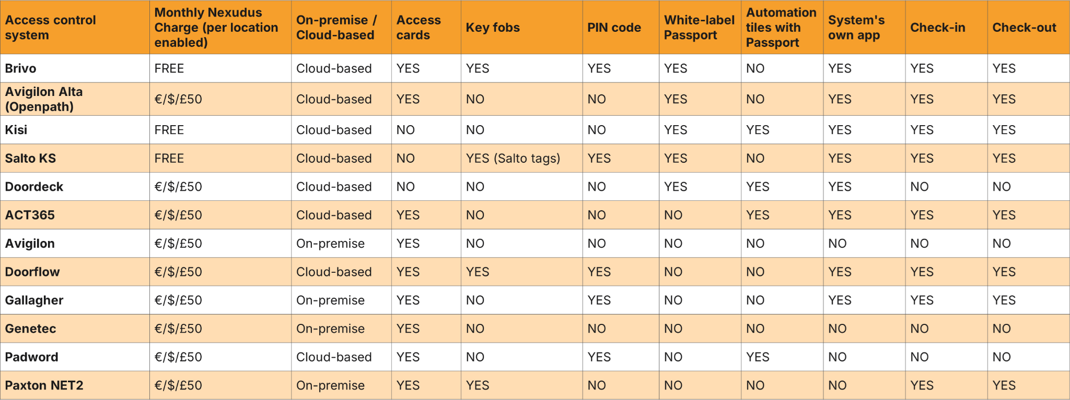
Any questions?

Access Groups
- The physical locks/door hardware in the customer’s space is linked to the access control system which is then controlled by access groups. Access groups are how you can control which doors customers can unlock.

- For example, to access the Nexudus meeting room, you’d need access to the main entrance of Chester House and the Nexudus office, as those doors have locks, but the meeting room does not.

- The access groups are linked to a Nexudus item such as a pass, desk, or resource. When a customer purchases a pass, books a resource, or rents a desk, they are automatically added to the relevant access group which grants them access to the space. They can unlock the doors 15 minutes before their booking.

- Nexudus automatically removes customers from the access groups as their passes expire, their contracts are cancelled, or the end of their booking.

- When creating an access group, customers should think about all the doors that need unlocking to access a particular resource or building.

- We recommend creating one access group per pass and per resource so you can easily control customer access.

Team access to offices

If the team-paying customer of a team has a Desk/ Office linked to their Contract, access to this desk/ office will flow through to the other team members in the team.

Any questions?

Section 2: Do (15 mins)
Let’s see how the integration works for some of the key access control systems -

- Brivo
- Kisi
- Salto KS
- Avigilon Alta (formerly OpenPath)

Kisi
https://web.kisi.io/
nexudus_opens_doors@nexudus.com
Nexudus13579!

Brivo:

https://login.brivo.com/
chris@nexudus.com
Nexudus1234$

Salto

https://app.saltoks.com/

chris+salto@nexudus.com
Nexudus1234$

Openpath

marcin@nexudus.com

Demo1234!!Demo1234!!

Section 3: Apply

Access control system | Monthly Nexudus Charge (per location enabled) | On-premise / Cloud-based | Access cards | Key fobs | PIN code
Brivo | FREE | Cloud-based | YES | YES | YES
Avigilon Alta (Openpath) | €/$/£50 | Cloud-based | YES | NO | NO
Kisi | FREE | Cloud-based | NO | NO | NO
Salto KS | FREE | Cloud-based | NO | YES (Salto tags) | YES
Doordeck | €/$/£50 | Cloud-based | NO | NO | NO
ACT365 | €/$/£50 | Cloud-based | YES | NO | NO
Avigilon | €/$/£50 | On-premise | YES | NO | NO
Doorflow | €/$/£50 | Cloud-based | YES | YES | YES
Gallagher | €/$/£50 | On-premise | YES | NO | YES
Genetec | €/$/£50 | On-premise | YES | NO | NO
Padword | €/$/£50 | Cloud-based | YES | NO | YES
Paxton NET2 | €/$/£50 | On-premise | YES | YES | NO

Access control system | White-label Passport | Automation tiles with Passport | System's own app | Check-in | Check-out
Brivo | YES | NO | YES | YES | YES
Avigilon Alta (Openpath) | YES | NO | YES | YES | YES
Kisi | YES | YES | YES | YES | YES
Salto KS | YES | NO | YES | YES | YES
Doordeck | YES | YES | YES | NO | NO
ACT365 | NO | YES | YES | YES | YES
Avigilon | NO | NO | NO | NO | NO
Doorflow | NO | NO | YES | YES | YES
Gallagher | NO | NO | YES | YES | YES
Genetec | NO | NO | NO | NO | NO
Padword | NO | YES | NO | NO | NO
Paxton NET2 | NO | NO | NO | YES | YES

